**Task 4**

**Project: Movie Rental Analysis System (using Redshift or PostgreSQL)**

**Objective:**

**Perform advanced analysis on movie rental data using OLAP operations.**

**The project will include the following tasks:**

**Database Creation:**

Create a database named MovieRental.

Create table rental_data with columns:

MOVIE_ID (integer),

CUSTOMER_ID (integer),

GENRE (varchar),

RENTAL_DATE (date),

RETURN_DATE (date),

RENTAL_FEE (numeric).

**Data Creation:**

Insert 10–15 sample rental records.

**OLAP Operations:**

a) Drill Down: Analyze rentals from genre to individual movie level.

b) Rollup: Summarize total rental fees by genre and then overall.

c) Cube: Analyze total rental fees across combinations of genre, rental date, and

customer.

d) Slice: Extract rentals only from the ‘Action’ genre.

e) Dice: Extract rentals where GENRE = 'Action' or 'Drama' and RENTAL_DATE is in

the last 3 months.

Create table –

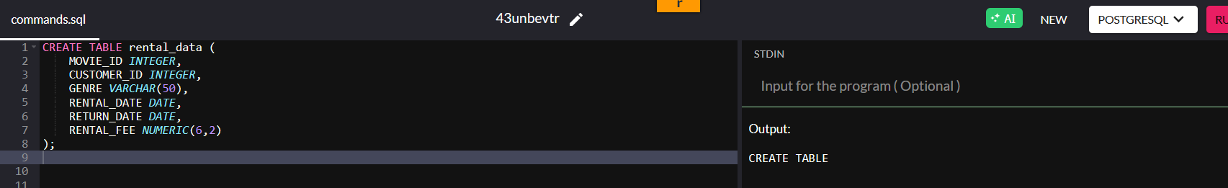

Insert data

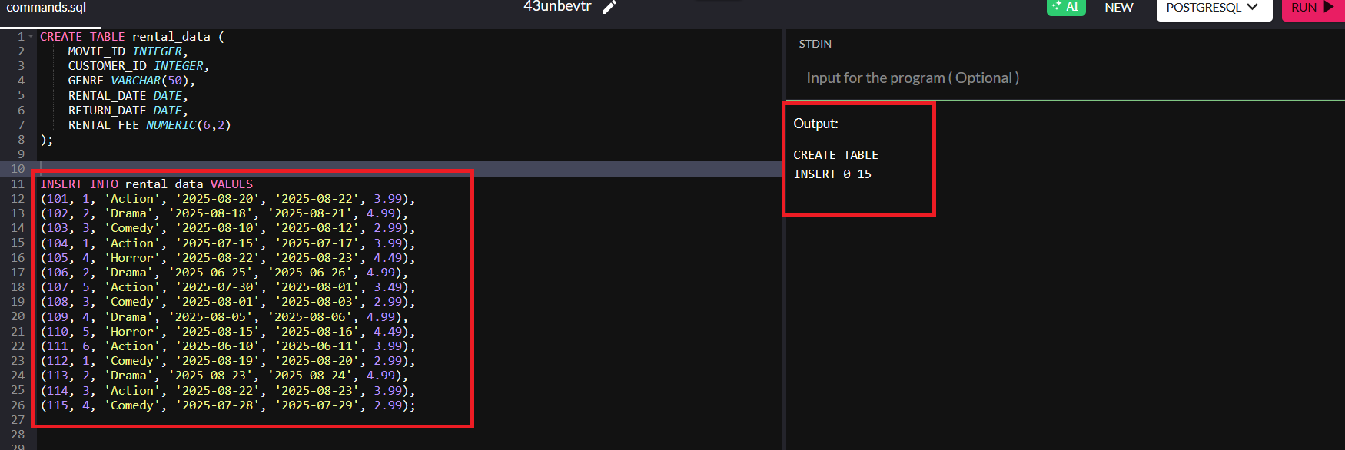

**OLAP Operations:**

a) Drill Down: Analyze rentals from genre to individual movie level.

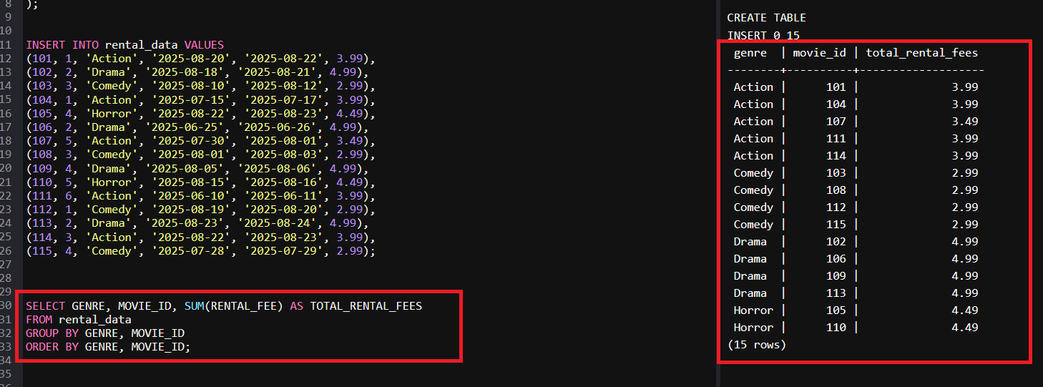

b) Rollup: Summarize total rental fees by genre and then overall.

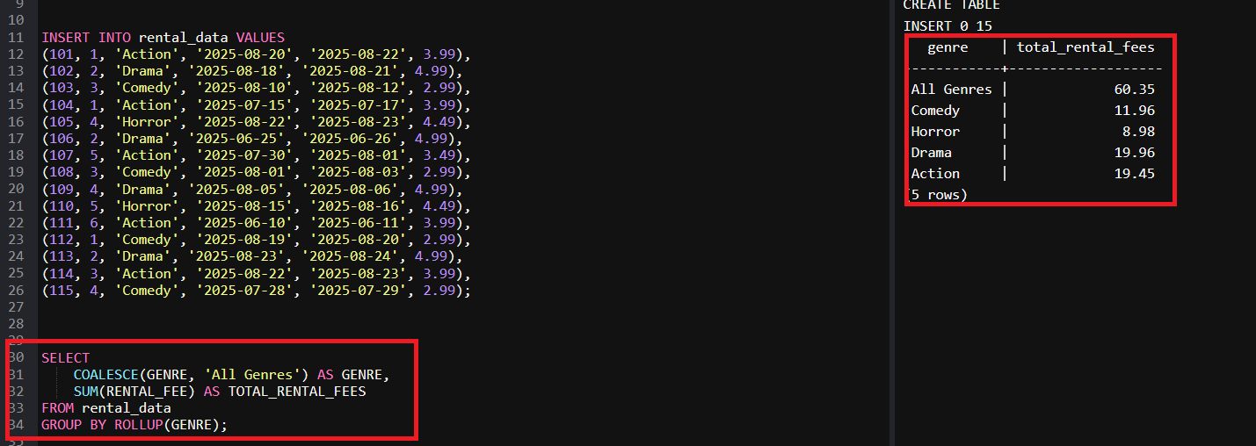

c) Cube: Analyze total rental fees across combinations of genre, rental date, and customer.  
Query

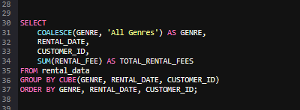

output  
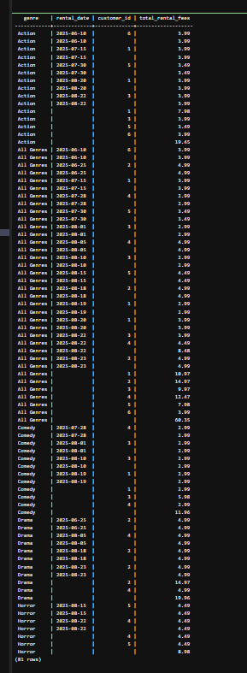

d) Slice: Extract rentals only from the ‘Action’ genre.

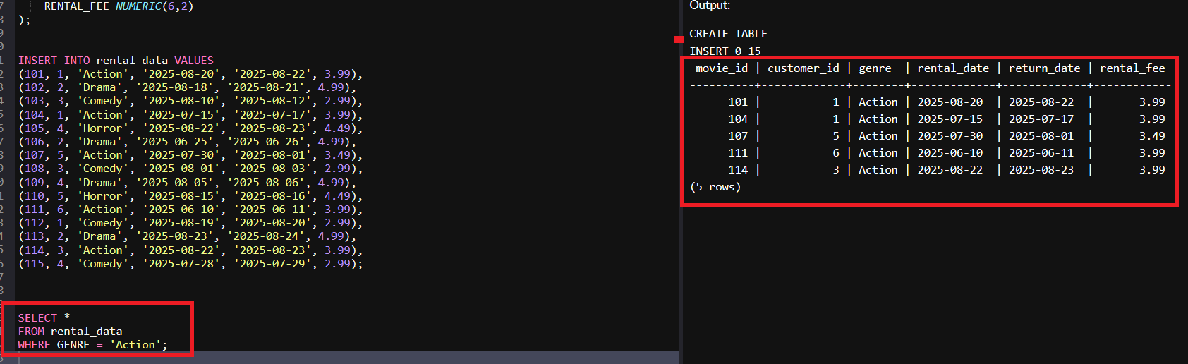

e) Dice: Extract rentals where GENRE = 'Action' or 'Drama' and RENTAL_DATE is in the last 3 months.

